**MODEL EXAM 1**

Name: KadiyalaNaresh

Rg.no.: 192110312

Course: object oriented C++

Code: DSA0163

**1.)Write a c++ program create a class called person that has private data members for name,age and country import member function get set three of variable.**

#include<iostream>

using namespace std;

class person{

private:

string name;

int age;

string country;

public:

void set(){

cout<<"Enter Name: ";

cin>>name;

cout<<"Enter Age: ";

cin>>age;

cout<<"Enter courty: ";

cin>>country;

}

void display(){

cout<<name<<age<<country;

}

};

int main(){

person person1;

person1.set();

person1.display();

return 0;

}

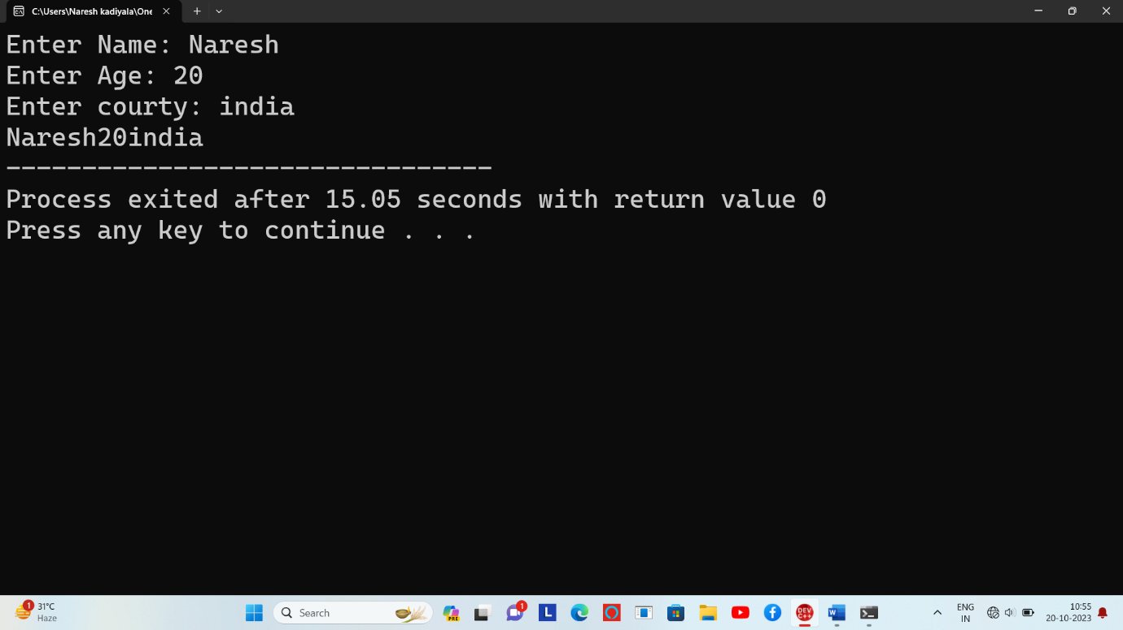

2.)**write a c++ program rectangle with two data member length and width and fuction to calculate the area.the cls 3 constructor. No parameter having,**

#include <iostream>

using namespace std;

class Rectangle {

private:

double length;

double width;

public:

Rectangle() {

length = 0.0;

width = 0.0;

}

Rectangle(double l, double w) {

length = l;

width = w;

}

Rectangle(double size) {

length = size;

width = size;

}

double calculateArea() {

return length * width;

}

};

int main() {

Rectangle rect1;

cout << "Area of rect1: " << rect1.calculateArea() << endl;

Rectangle rect2(5.0, 3.0);

cout << "Area of rect2: " << rect2.calculateArea() << endl;

Rectangle square(4.0);

cout << "Area of square: " << square.calculateArea() << endl;

return 0;

}

**Output:**

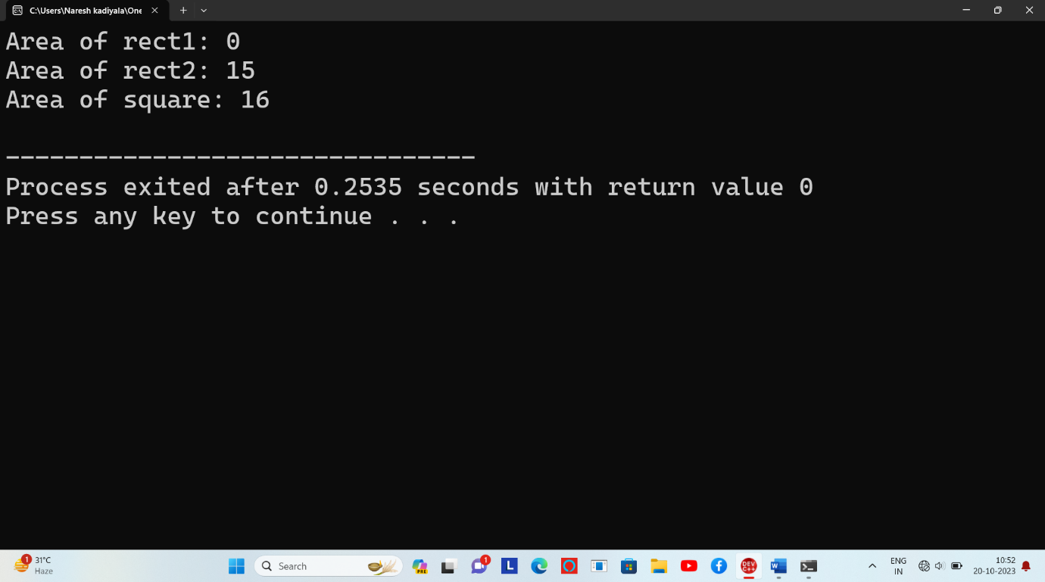

**3.)pattern**

Code:-

#include<iostream>

using namespace std;

int main(){

int i,n;

cout<<"Enter a number: ";

cin>>n;

for(int i=1;i<=n;i++){

for(int j=1;j<=i;j++){

cout<<" 1";

}

cout<<endl;

}

return 0;

}

**Output:**

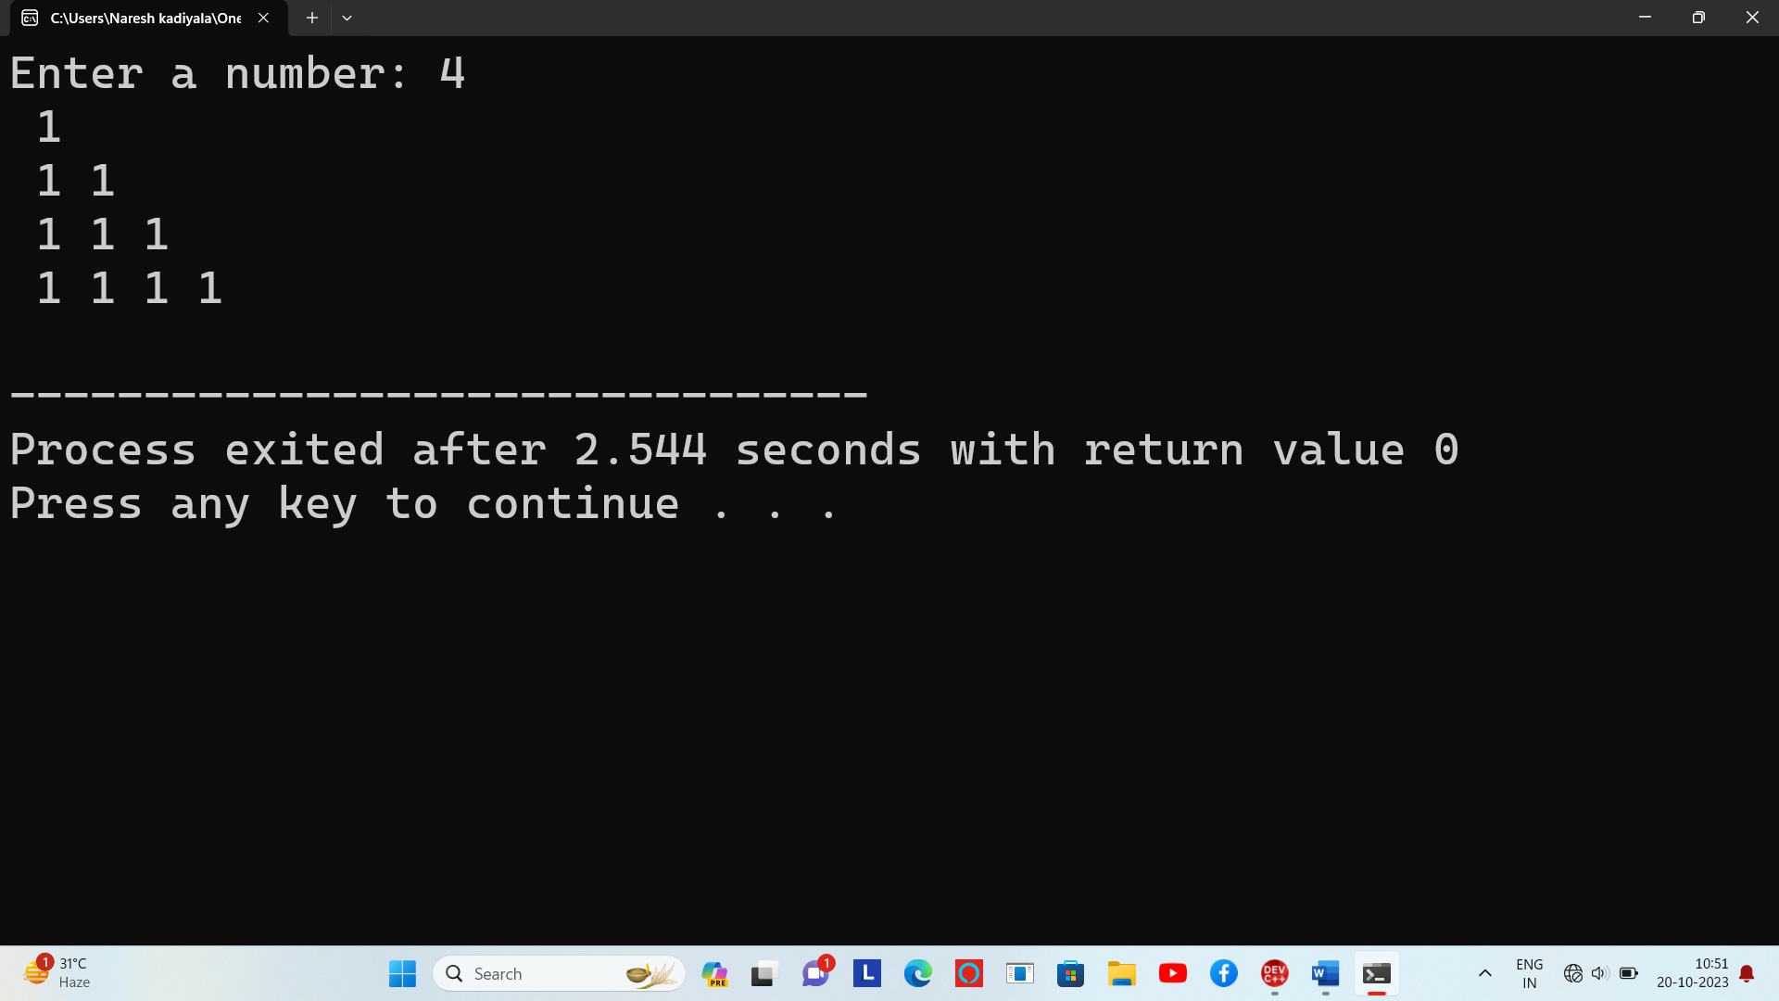

4.)

#include <iostream>

#include <string>

#include <vector>

class Person {

public:

Person(const std::string& name, int age)

: name(name), age(age) {}

std::string getName() const {

return name;

}

int getAge() const {

return age;

}

private:

std::string name;

int age;

};

class Student {

public:

Student(const std::string& name, int rollNo, const Person& person)

: name(name), rollNo(rollNo), person(person) {}

void addSubject(const std::string& subject, double mark) {

subjects.push_back(std::make_pair(subject, mark));

}

double calculateTotalMarks() {

double total = 0.0;

for (const auto& subject : subjects) {

total += subject.second;

}

return total;

}

double calculateAverageMarks() {

double total = calculateTotalMarks();

return (total / subjects.size());

}

void displayStudentInfo() {

std::cout << "Name: " << name << std::endl;

std::cout << "Roll No: " << rollNo << std::endl;

std::cout << "Person Info - Name: " << person.getName() << ", Age: " << person.getAge() << std::endl;

std::cout << "Subjects and Marks:" << std::endl;

for (const auto& subject : subjects) {

std::cout << subject.first << ": " << subject.second << std::endl;

}

std::cout << "Total Marks: " << calculateTotalMarks() << std::endl;

std::cout << "Average Marks: " << calculateAverageMarks() << std::endl;

}

private:

std::string name;

int rollNo;

Person person;

std::vector<std::pair<std::string, double>> subjects;

};

int main() {

Person person("John Doe", 20);

Student student("Alice", 12345, person);

student.addSubject("Math", 95.5);

student.addSubject("Physics", 88.0);

student.addSubject("Chemistry", 92.5);

student.displayStudentInfo();

return 0;

}

